Grove - Light Sensor

|  |
| --- |
| **Contents**   [[hide](javascript:toggleToc())]   * [1 Introduction](http://www.seeedstudio.com/wiki/Grove_-_Light_Sensor#Introduction) * [2 Features](http://www.seeedstudio.com/wiki/Grove_-_Light_Sensor#Features) * [3 Specifications](http://www.seeedstudio.com/wiki/Grove_-_Light_Sensor#Specifications) * [4 Usage](http://www.seeedstudio.com/wiki/Grove_-_Light_Sensor#Usage) * [5 Resources](http://www.seeedstudio.com/wiki/Grove_-_Light_Sensor#Resources) |

Introduction

The light sensor, also known as the light dependent resistor (LDR), is a commonly used sensor in a wide variety of applications from DIY projects to industrial automation. Typically the resistance of the light sensor decreases when the ambient light intensity increases.  
Model:[SEN11302P](http://www.seeedstudio.com/depot/grove-light-sensor-p-746.html?cPath=144_148)

[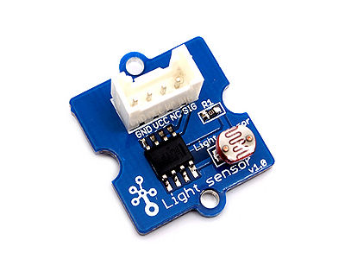](http://www.seeedstudio.com/wiki/File:Twig-Light.jpg)  
There has another production - Grove - Light Sensor (P). What does “P” mean? “P” is for “panel mount” in this product.It is the sister version of Grove -Light Sensor.They are identical except the Grove connecter is moved to the back so that you can easily use it as a neat and wire-free human interface device.  
Model:[SEN08211P](http://www.seeedstudio.com/depot/grove-light-sensorp-p-1253.html?cPath=144_148)   
[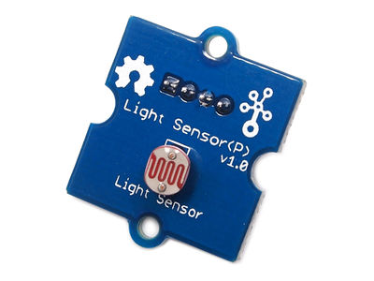](http://www.seeedstudio.com/wiki/File:Grove_-_Light_SensorP1.jpg)[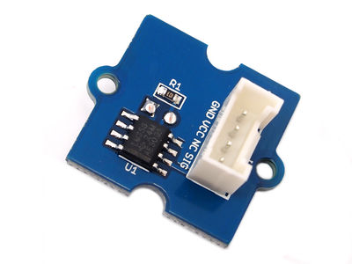](http://www.seeedstudio.com/wiki/File:Grove-LightSensorP2.jpg)

Features

* One of the most widely used sensors
* Accept wide range of input voltage: 3V–30V
* Good for beginner's experiment
* Grove plug-and-play interface

Specifications

|  |  |  |  |  |  |
| --- | --- | --- | --- | --- | --- |
| **Item** | **Conditions** | **Min** | **Typical** | **Max** | **Unit** |
| **Voltage** | - | 3 | 5 | 30 | V |
| **Supply Current** | - | 0.5 | - | 3 | mA |
| **Light resistance** | 10lux | 8 | - | 20 | kΩ |
| **Dark resistance** | 0lux | - | 1 | - | MΩ |
| **Reponse time** | Rising | - | 20 | - | S |
| Falling | - | 30 | - | S |
| **Peak Wavelength** | - | - | 540 | - | nm |
| **Ambient temperature** | - | -30 | - | +70 | ℃ |

Usage

The Grove - Light Sensor is an analog device that outputs analog signal ranging from 0 - 1024. That requires we use the analog port of Arduino to take the readings.

Here is an example of light-controlled LED. When environment gets darker than threshold we set, a LED lights up.

1. Connect the module to the Analog port 0 of [Grove - Basic Shield](http://www.seeedstudio.com/wiki/Grove_-_Base_Shield) using the 4-pin grove cable and connect LED to Pin 12.  
2. Plug the Grove - Basic Shield into Arduino.  
[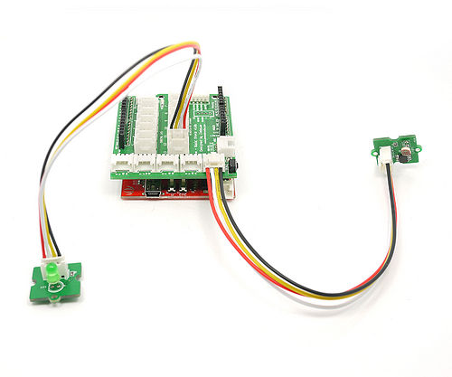](http://www.seeedstudio.com/wiki/File:Light_LED.jpg)   
3. Connect Arduino to PC by using a USB cable.   
4. Copy and paste code below to a new Arduino sketch. Please click [here](http://www.seeedstudio.com/wiki/Upload_Code) if you do not know how to upload.

/*

/* Grove - Light Sensor demo v1.0

*

* signal wire to A0.

* By: http://www.seeedstudio.com

*/

#include <math.h>

const int ledPin=12; //Connect the LED Grove module to Pin12, Digital 12

const int thresholdvalue=10; //The treshold for which the LED should turn on. Setting it lower will make it go on at more light, higher for more darkness

float Rsensor; //Resistance of sensor in K

void setup() {

Serial.begin(9600); //Start the Serial connection

pinMode(ledPin,OUTPUT); //Set the LED on Digital 12 as an OUTPUT

}

void loop() {

int sensorValue = analogRead(0);

Rsensor=(float)(1023-sensorValue)*10/sensorValue;

if(Rsensor>thresholdvalue)

{

digitalWrite(ledPin,HIGH);

}

else

{

digitalWrite(ledPin,LOW);

}

Serial.println("the analog read data is ");

Serial.println(sensorValue);

Serial.println("the sensor resistance is ");

Serial.println(Rsensor,DEC);//show the ligth intensity on the serial monitor;

delay(1000);

}

5. You can check the resistance of the LDR after opening the Serial Monitor.

[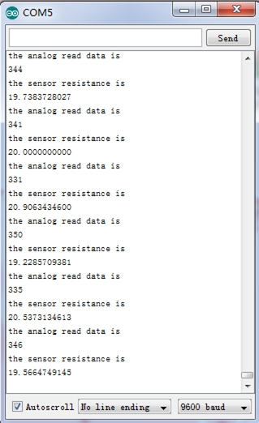](http://www.seeedstudio.com/wiki/File:Light_Sensor.jpg)

To find out the physical meaning of the resistance you got. You can refer to the resistance curve of LDR GL5528 below. The intensity of light is measured by lux.   
[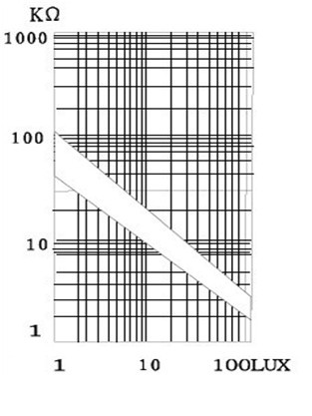](http://www.seeedstudio.com/wiki/File:GL5528photoresistor.jpg)

Resources

* [Eagle Files](http://garden.seeedstudio.com/images/7/79/Light_sensor.zip)
* [LM358pdf](http://garden.seeedstudio.com/images/d/d2/LM358.pdf)